**28)**

**Aim:** Design DFA using simulator to accept the string the end with ab over set {a,b)

W= abbaabab.

**Diagram:**

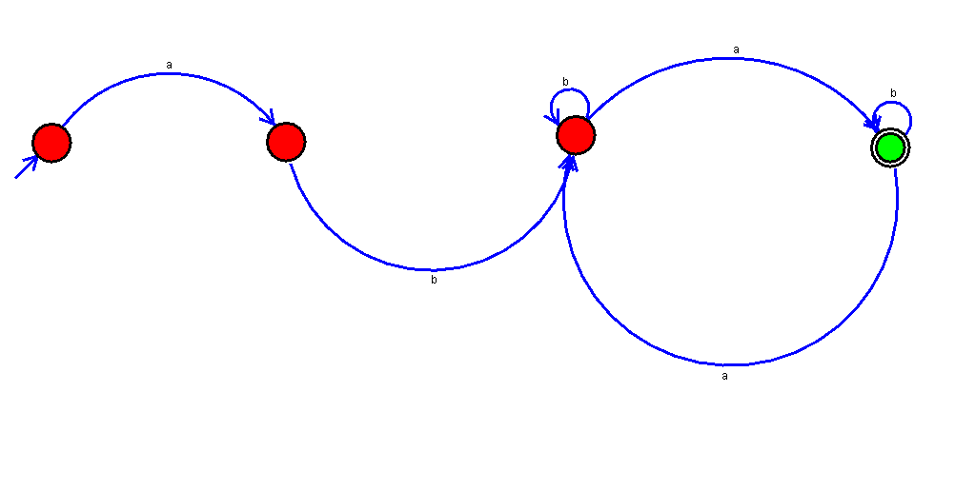

**Result:**

Thus, successfully executed DFA using simulator to accept the string the end with ab over set {a,b) W=abbaabab.